**Advanced Tableau IV**

**Adeel Nasir**

1. **Showing statistics and forecasting: use the analytics pane and trend lines:**

(1). Build a trend line between weight and standard cost, enable confidence interval, are the correlation coefficient between these two facts significant?

These are significantly and negatively correlated

**Generate a forecast in the View: build a forecast line to predict the sum of sales amount in 2015 (order date)**

**2. Find Clusters in Data:**

Find clusters in the scatterplot of weight and product cost from production dimension; How many clusters are generated automatically? Distinguish these clusters using different colors;

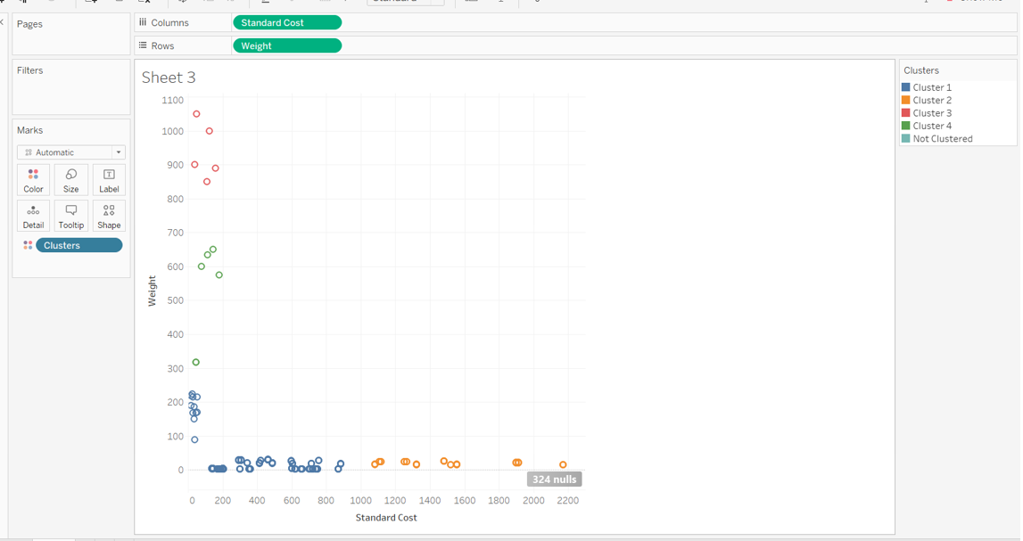

**(2). Display only cluster 1 and cluster 2 in the view; Save clusters as groups in the data field, and rename the groups;**

**4. Use Control Chart with Control Limit:**

**(1). Build a control chart, with average, and upper limit and lower limit;**

**(2). Highlight the nodes that outside the upper and lower limit;**

